钤盖研究生院学历、学位证明专用章申请表
编号：泉〔20XX〕__号
用印单位 | 2008级汉语言文字学专业硕士生张三（2011.6毕业） |  |  |  |  |  |  | 拟盖印章 | 研究生院学历、学位证明章
所盖材料目录 | 1 |  | 张三学历证明 |  |  |  |  | 份数 | 1份
所盖材料目录 | 2 |  | 张三学位证明 |  |  |  |  | 份数 | 1份
所盖材料目录 | 3 |  |  |  |  |  |  | 份数
所盖材料目录 | 4 |  |  |  |  |  |  | 份数
所盖材料目录 | 5 |  |  |  |  |  |  | 份数
所盖材料目录 | 6 |  |  |  |  |  |  | 份数
致何部门 | 学生本人 |  |  | 申请人签名 |  |  |  | 申请  时间
用印单位领导审核 | 签名：  年 月 日
经办人 |  |  |  |  |  | 审核人
备注 |  | 附件张三学历、学位证书复印件

Master’s Diploma

NO. 103851201102000XXX
Zhang San , female, born on June 1st, 1984, was a graduate student majoring in Chinese Philology from September, 2008 to June, 2011. The length of the program is three years. Having fulfilled all courses stipulated in master postgraduate training plan with qualified achievements and passed the oral defense of her graduation thesis, she has been awarded this diploma.
Training Unit: Huaqiao University
President: Qiu Jin
June 21st , 2011

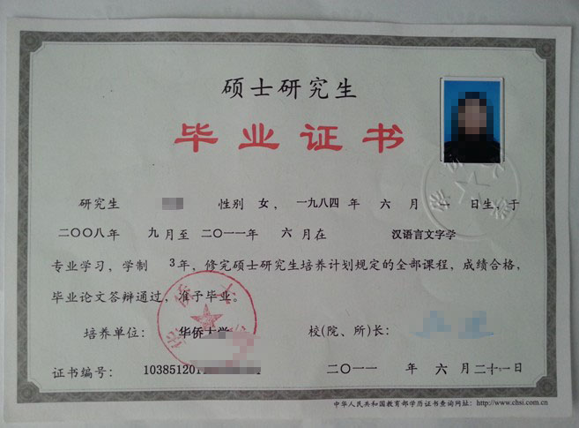

CERTIFICATE OF MASTER’S DEGREE

No. 1038532011000XXX
Zhang San , female, born on June 1st, 1984, having majored in Chinese Philology at Huaqiao University and having passed the prescribed master's degree courses and the oral defense of her master's graduation thesis with qualified achievement. According to the requirements of the Regulations of the People's Republic of China on Academic Degrees, she is hereby awarded the Degree of Master of Literature.
President: Qiu Jin
Chairman of the Academic Degrees Evaluation Committee: Qiu Jin
June 22nd , 2011

